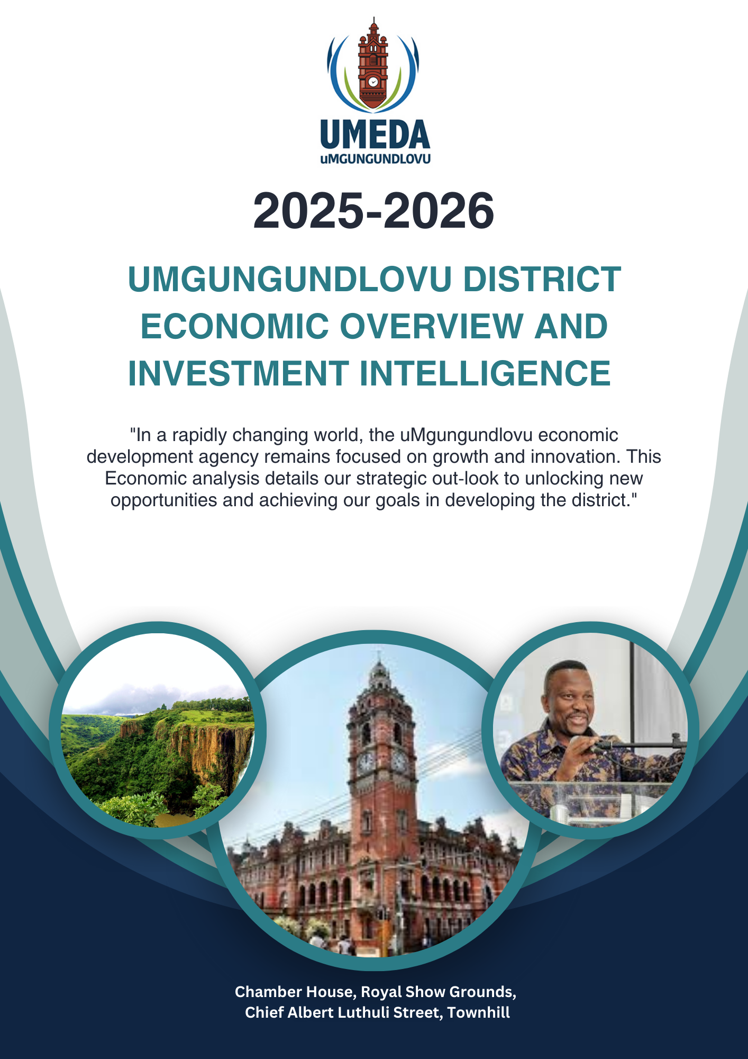

Table of Contents
1. UMGUNDUNDLOVU DISTRICT DEMOGRAPHICS (SENSUS 2022) 1
a. Population 1
b. Total Population Data for UMDM District’s local municipalities 1
c. Key Statistics 1
d. Ranking (District) 2
e. Population group 2
f. Access to piped water 2
g. Main toilets Facilities 2
h. Energy for Cooking 2
2. JOBS GROWTH 2014 - 2024 3
3. INDUSTRY STRUCTURE 3
4. WAGE DISTRIBUTION (2024) 4
5. NEW JOBS (2014-2024) 4
6. TOTAL ECONOMIC GROWTH (2014 -2024) 5
7. JOB GROWTH BY SECTOR 6
7.1 Manufacturing | (1/3) 6
7.2 Manufacturing | (2/3) 7
7.3 Manufacturing | (3/3) 8
7.4 Agriculture, forestry and fishing 9
7.5 Mining and quarrying 10
7.6 Education 11
7.7 Electricity, gas, steam and air conditioning supply 12
Electricity Supply: 12
Gas, Steam, and Air Conditioning Supply: 12
Infrastructure Development: 12
7.8 Human health and social work activities 13
7.9 Construction 14
7.10 Wholesale and retail trade; repair of motor vehicles and motorcycles 15
7.11 Accommodation and food service activities 16
Accommodation and food service activities (Continue) 17
7.12 Transportation and storage 18
Transportation Infrastructure 18
Storage Facilities 18
Strategic Focus 18
8. INDUSTRY PROFILE (2024 19
9. Industry Potential: Four Quadrants (2014-2024 | All Industries) 20
10. Wage Inequality: Gini 21
11. Wage Levels: Median Income 21
12. Wage Distribution (2024 All Industries) 22
13. Jobs For Youth (2024) 23
14. TOURISM TRENDS 24
15. TRANSPORT TRENDS 27
16. Role and advantage of the Informal Economy 28
17. The Educational Sector in uMgungundlovu District 29
17.1 Tertiary Education and Vocational Training 29
17.2 Private Schools: 30

UMGUNDUNDLOVU DISTRICT DEMOGRAPHICS (SENSUS 2022)

Female | Male | Education Institution  Attendance (5-24 Years) | Household in Formal  Dwellings | Access to Piped water  Dwelling
52,3% | 47,7% | 71,9% | 88,6% | 51,1%

Population
1 235 715

Key statistics for uMgungundlovu, including population size, age distribution, sex ratios and household indicators such as type of dwelling, access to piped water, energy used for lighting and refuse disposal are presented on this page. The indicators are presented and can be viewed graphically for three themes; population, education and household living conditions and uMgungundlovu is ranked according to its population size.

Total Population Data for UMDM District’s local municipalities

Impendle | 36648
Mkhambathini | 61660
Mpofana | 33382
Richmond | 62754
Msunduzi | 817725
uMngeni | 105069
uMshwathi | 118478

Key Statistics
Name | 2022 | 2011
Total population | 1 235 715 | 1 014 572
Young children (0-14 years) | 24,5% | 28,3%
Working age population (15-64 years) | 68,4% | 66,4%
Elderly (65+ years) | 7,2% | 5,3%
Dependency ratio | 46,3 | 50,5
Sex ratio | 91,1 | 91,5
No schooling (20+ years) | 5,6% | 8,3%
Higher education (20+ years) | 13,1% | 10,8%
Number of households | 307 842 | 272 357
Average household size | 4,0 | 3,7
Formal dwellings | 88,6% | 70,8%
Flush toilets connected to sewerage | 58,3% | 49,5%
Weekly refuse disposal service | 52,8% | 44,4%
Access to piped water in the dwelling | 51,1% | 42,8%
Electricity for lighting | 97,3% | 86,5%

Ranking (District)
Name | Population size | Rank
eThekwini | 4 239 901 (Metro) | 1
uMgungundlovu | 1 235 715 | 2
King Cetshwayo | 1 021 344 | 3
Zululand | 942 794 | 4
uThukela | 789 092 | 5
iLembe | 782 661 | 6
Ugu | 773 402 | 7
Umkhanyakude | 738 437 | 8
Amajuba | 687 408 | 9
uMzinyathi | 649 261 | 10
Harry Gwala | 563 893 | 11

Population group
Name | Frequency | %
BLACK AFRICAN | 1 003 061 | 81,2%
COLOURED | 28 017 | 2,3%
INDIAN/ASIAN | 126 618 | 10,2%
WHITE | 74 039 | 6,0%
OTHER | 3 586 | 0,3%

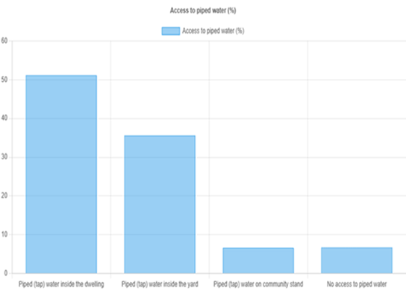
Access to piped water

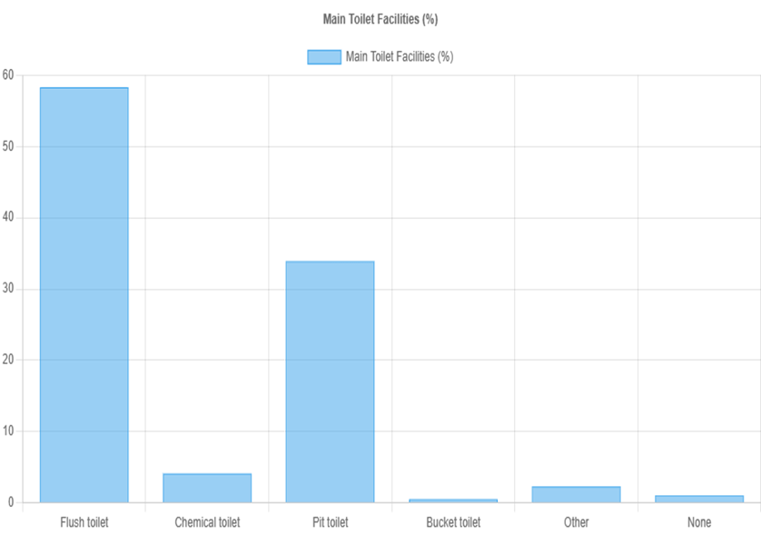
Main toilets Facilities

h. Energy for Cooking
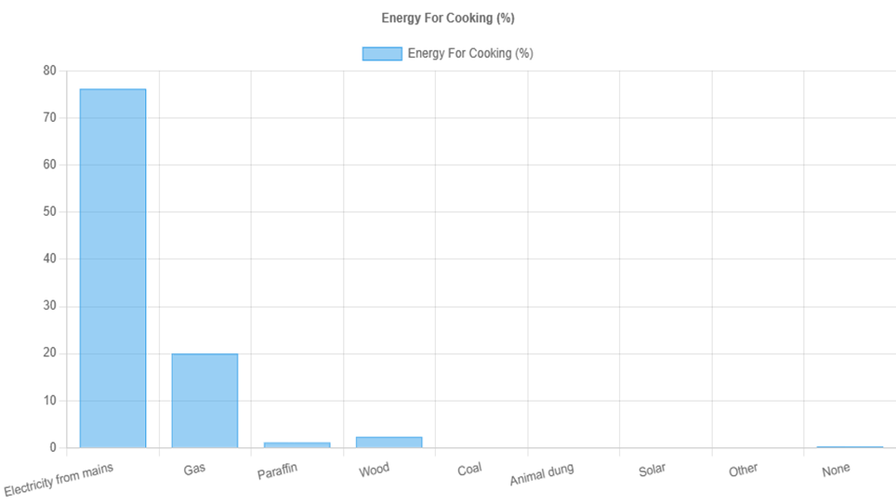

JOBS GROWTH 2014 - 2024
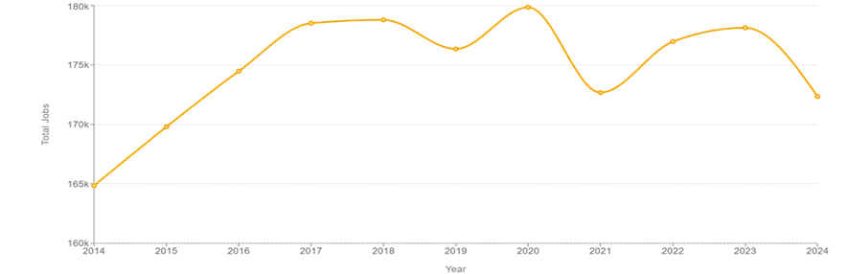

 Total jobs 172345

How many jobs are available in Umgungundlovu?
Jobs reported in the spatial tax panel are based on IRP5 certificates which are converted into 'Full Time Equivalents' (FTE), or in other words, full-time employment. The data covers employment by firms in the formal sector but excludes informal jobs where firms are not tax compliant. The total number of jobs is a critical indicator of the level of 'decent work' or size of the formal 'mainstream' economy.

INDUSTRY STRUCTURE

Which sector are the biggest employers in Umgungundlovu?
The top 10 sectors ranked here are most important for jobs and livelihoods. The economic outlook depends on the capacity of firms in these sectors to expand, adapt and innovate or otherwise risk becoming a drag on economic performance. Non-tradable sectors such as government services tend to be stable but are inherently constrained by the size of the local economy (i.e. local demand). Tradable sectors can compete in surrounding (and even international) markets but must be competitive to thrive.
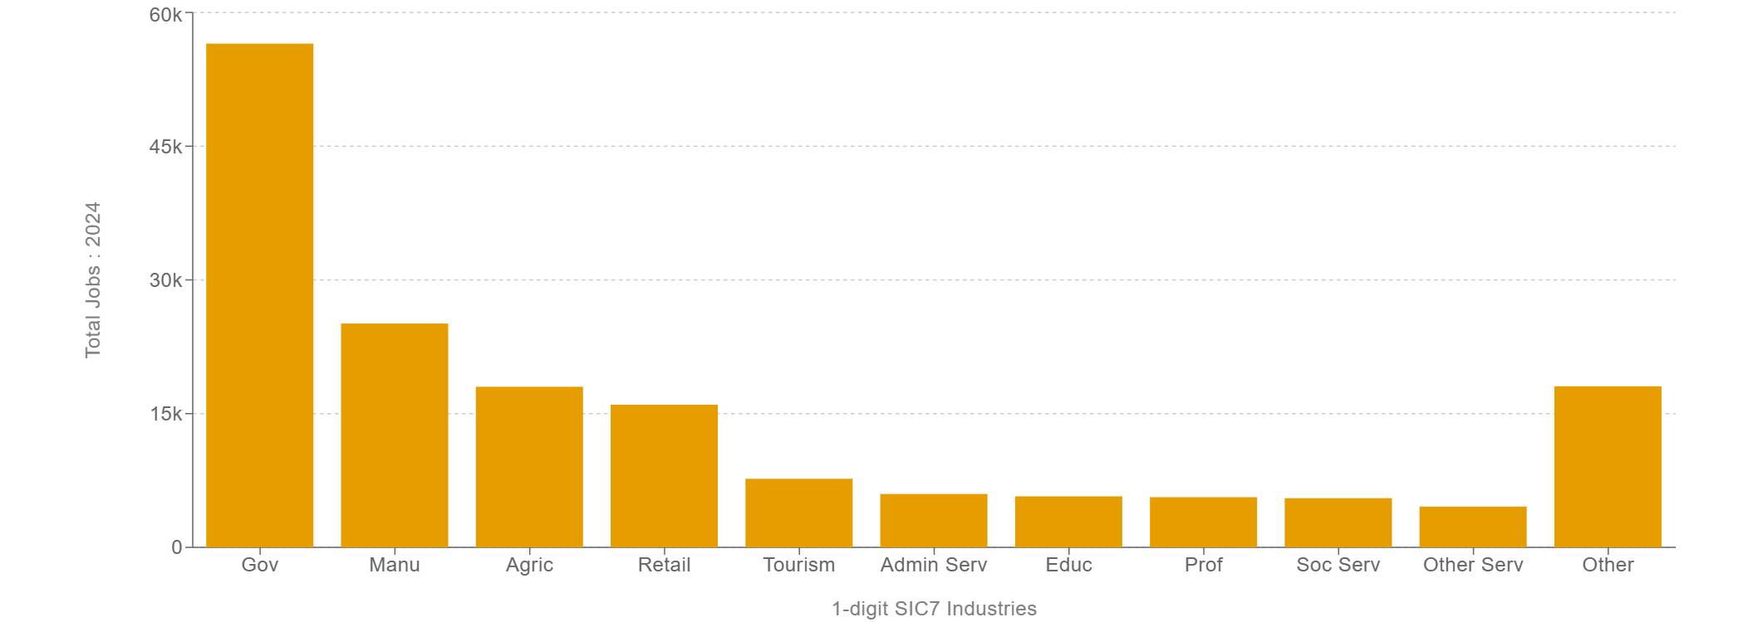

WAGE DISTRIBUTION (2024)
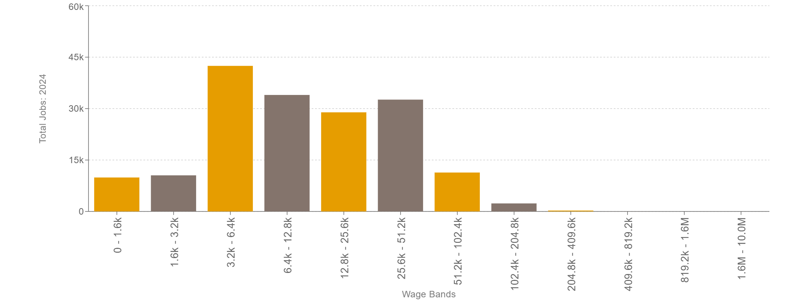

What do jobs pay for people working in Umgungundlovu?
The wage distribution shows the number of people who earn at a particular level in Rands per month. The level of earnings is closely related to demand-side factors such as the sector of employment as well as supply-side factors such as worker experience, education and occupation. The number of people in each wage category is important to bear in mind considering the local population that these jobs support.

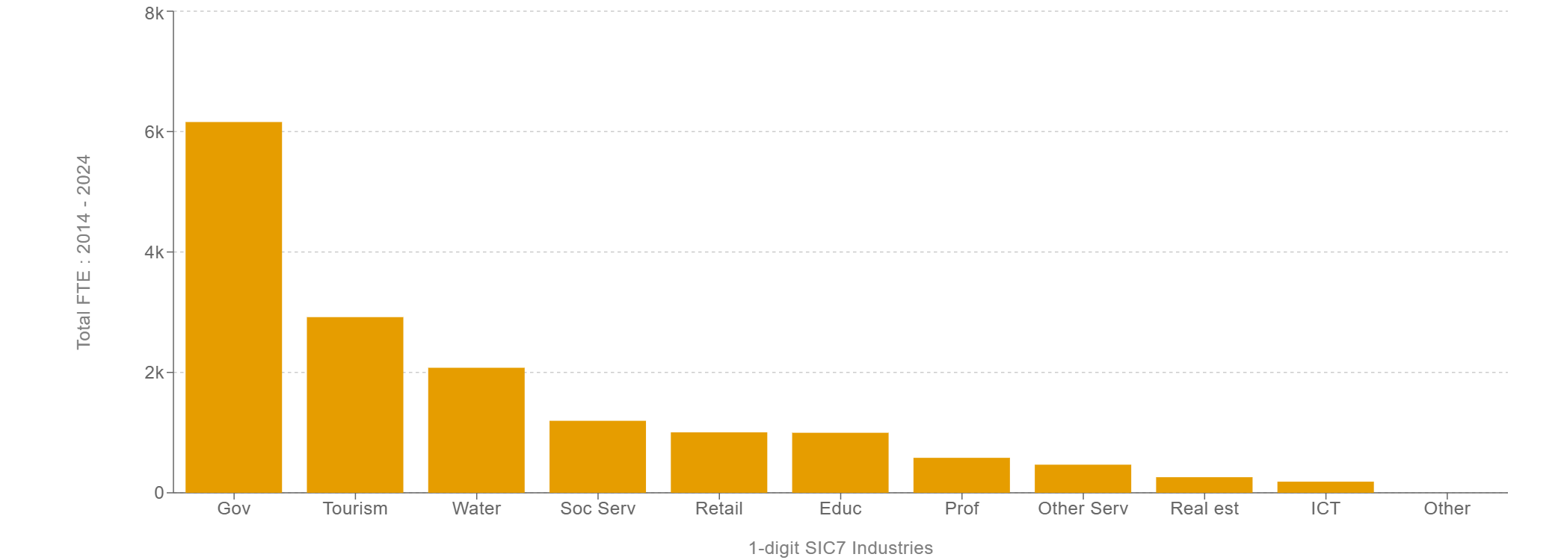
NEW JOBS (2014-2024)
The sectors which create the newest jobs have a critical role to play within
the local economy. Job creation can be driven by economic expansion in dynamic sectors. However, total jobs growth can also be related to industry size (or dominance) because modest and even low growth will add up to more jobs in large industries. In either case, these sectors mattered most for job creation.

TOTAL ECONOMIC GROWTH (2014 -2024)

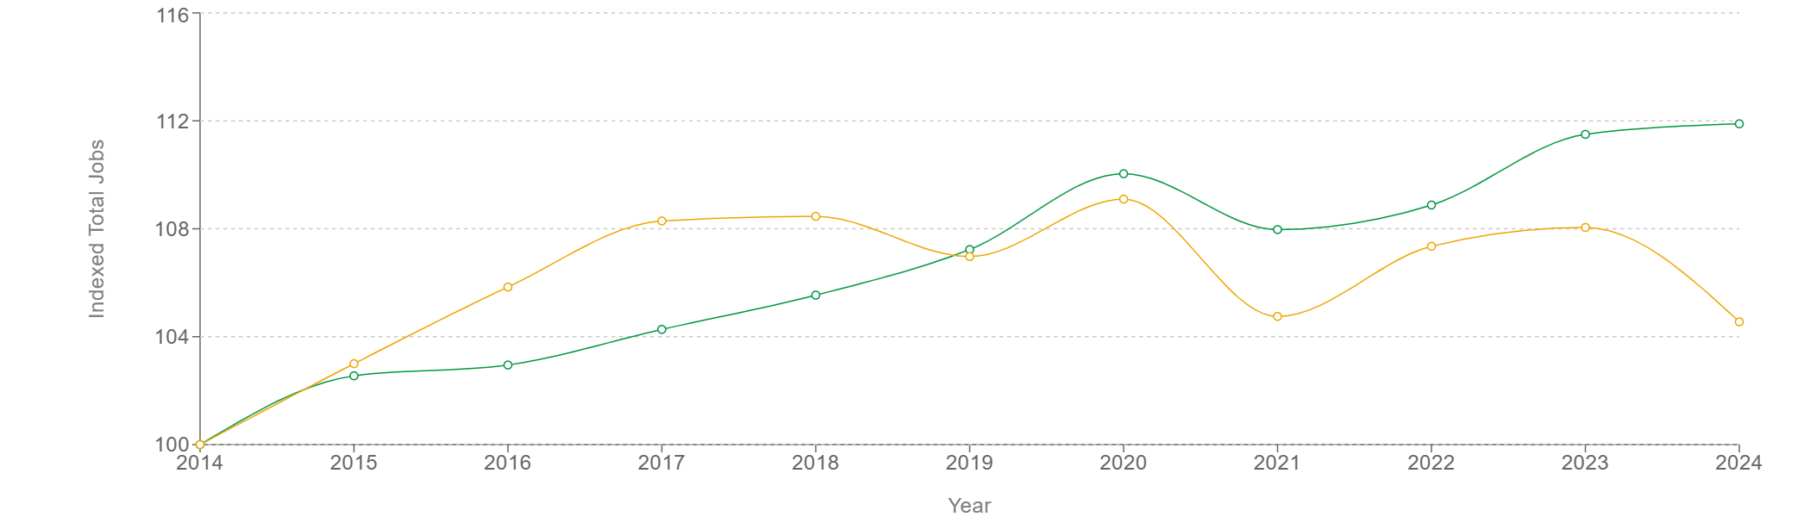

 | 2024
South Africa | 111.89
Umgungundlovu | 104.55
How does total jobs growth compare in Umgungundlovu?
Indexed total jobs show the relative performance of each region adjusted for its size in the starting year. It can also be interpreted as the total percentage change in jobs from the starting year by simply subtracting 100. Instability over time can be a consequence of a small economic base but also if the economy is stagnant which compresses the y-axis. Getting positioned above (or below) the ‘national’ benchmark implies that this local economy is pulling ahead (or falling behind) the rest of the country.

JOB GROWTH BY SECTOR

7.1 Manufacturing | (1/3)

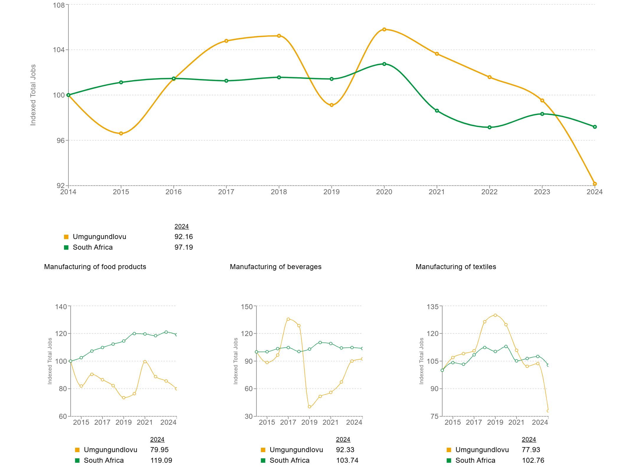
The uMgungundlovu District in KwaZulu-Natal, South Africa, boasts a dynamic manufacturing sector that significantly contributes to the region's economic vitality. Key industries include automotive, textiles, and agro-processing, all of which play pivotal roles in job creation and economic development. The district's strategic location along the N3 Corridor—the country's busiest logistics route—coupled with well-established infrastructure and access to key transportation networks, enhances its appeal for manufacturing activities
Manufacturing firms are primarily located in the Msunduzi, Mkhambathini (Camperdown), and uMngeni municipalities. Over the past decade, while certain sub-sectors like shoe production have experienced declines, others, such as aluminium processing, have emerged, reflecting the district's adaptability and resilience.

7.2 Manufacturing | (2/3)

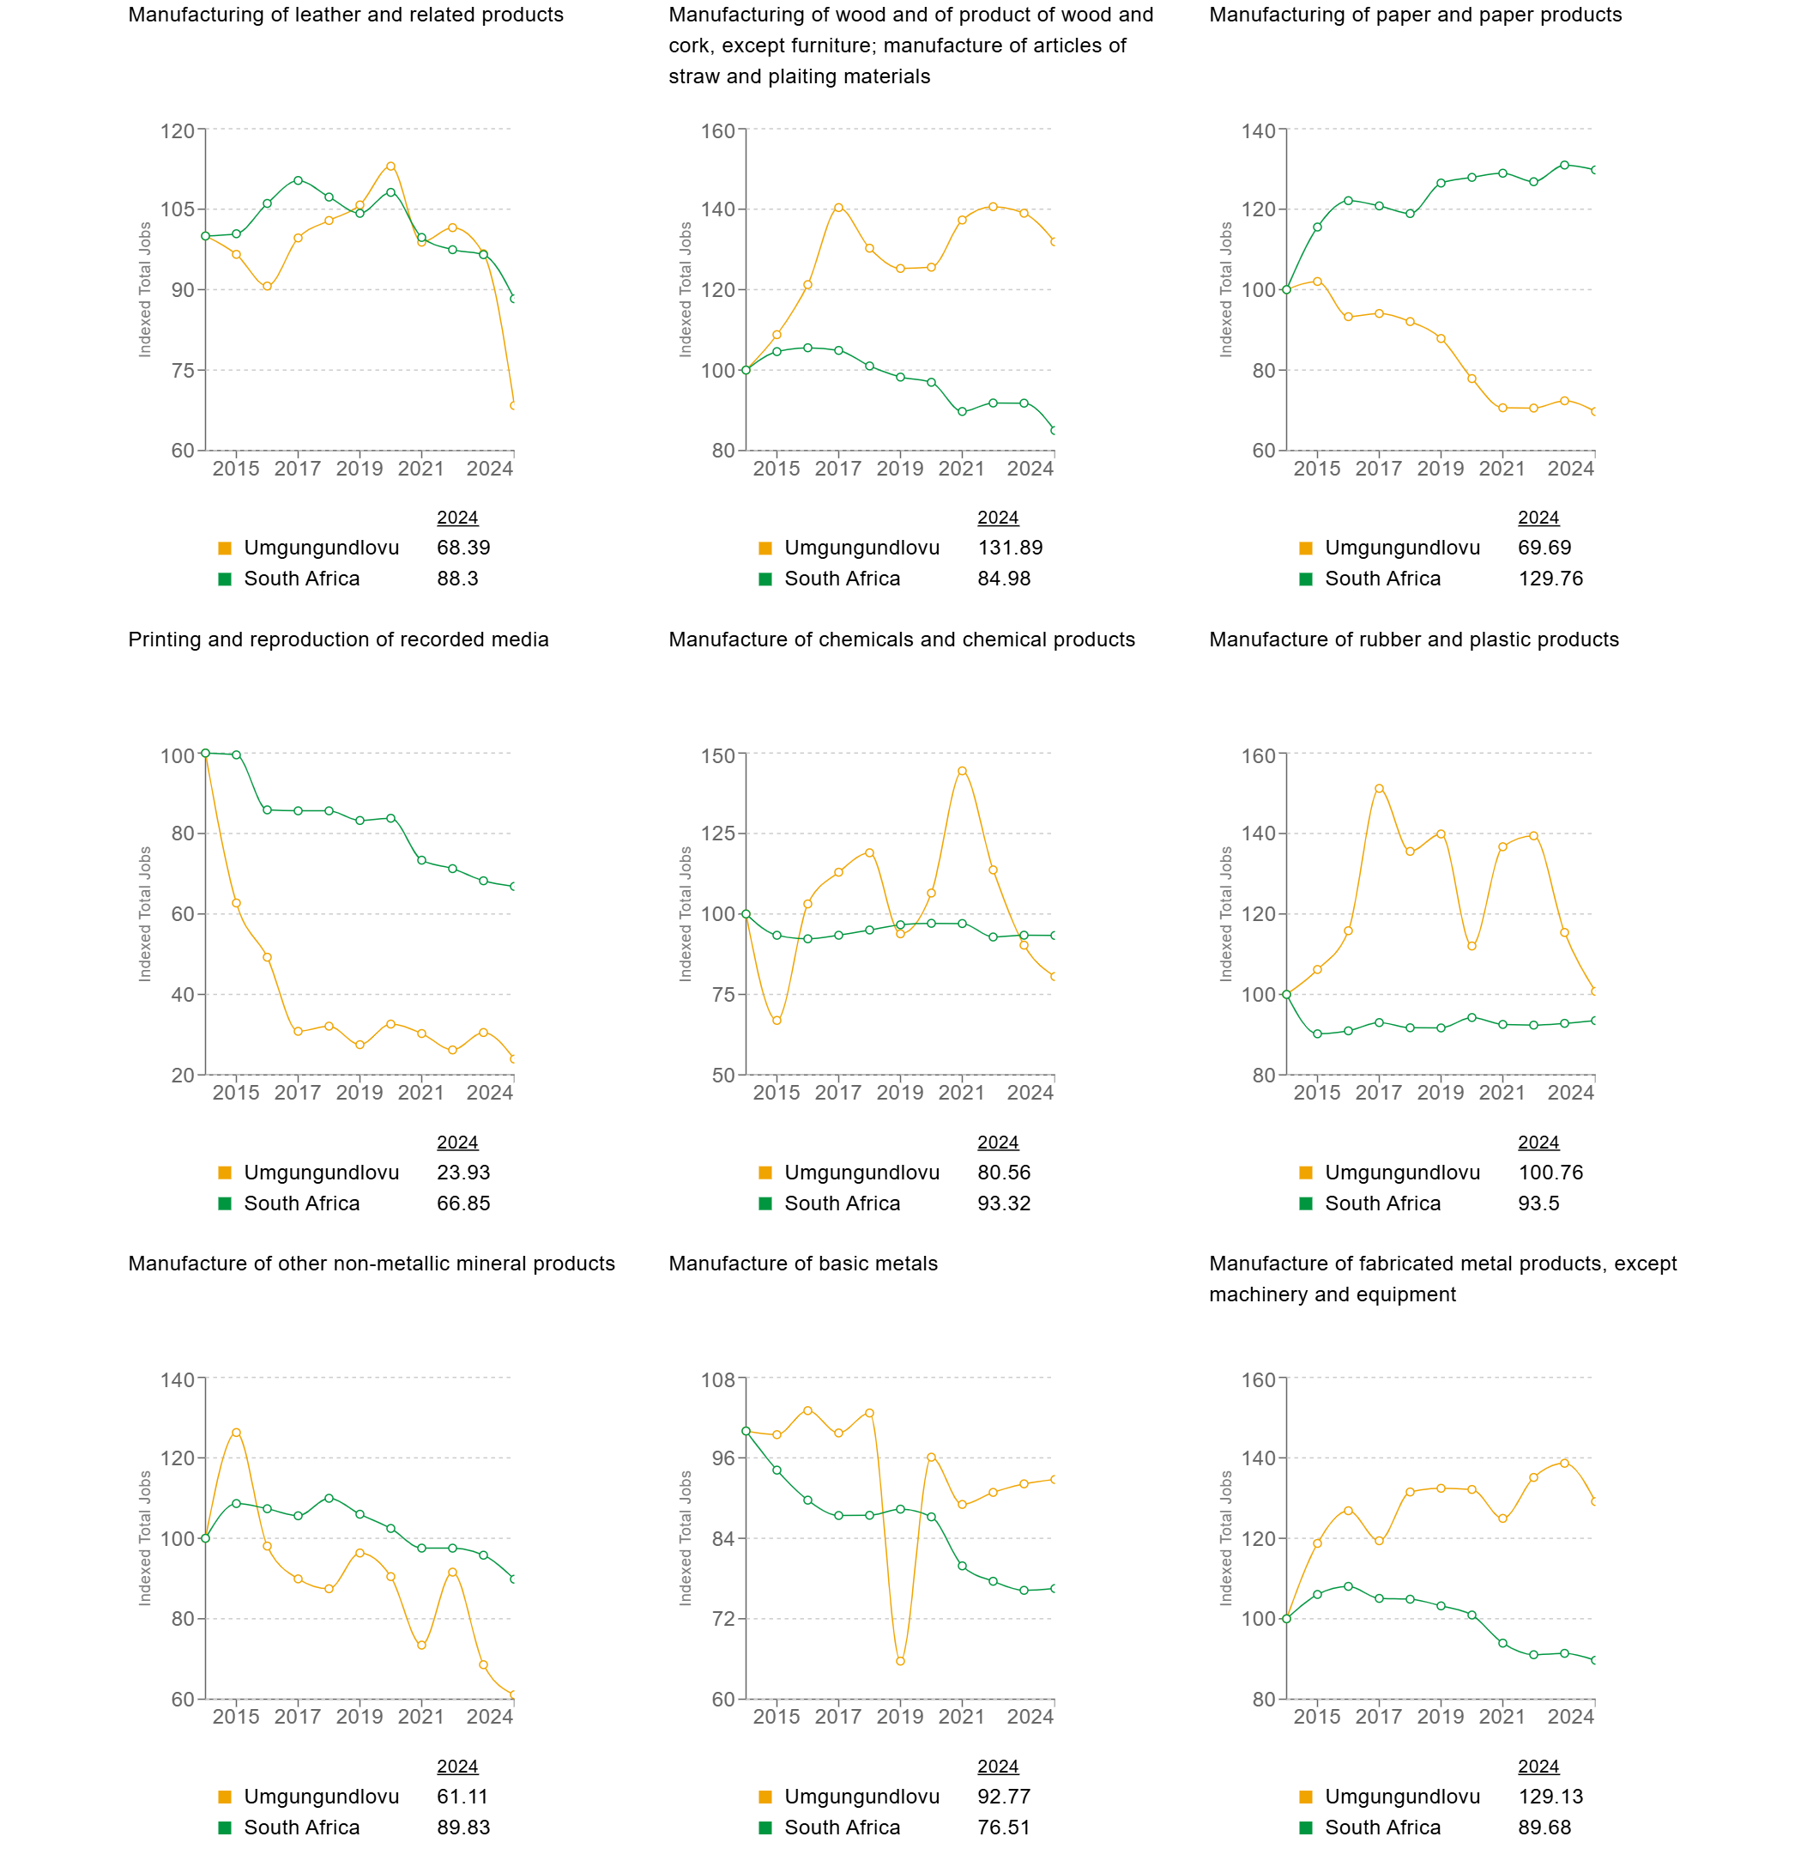

7.3 Manufacturing | (3/3)

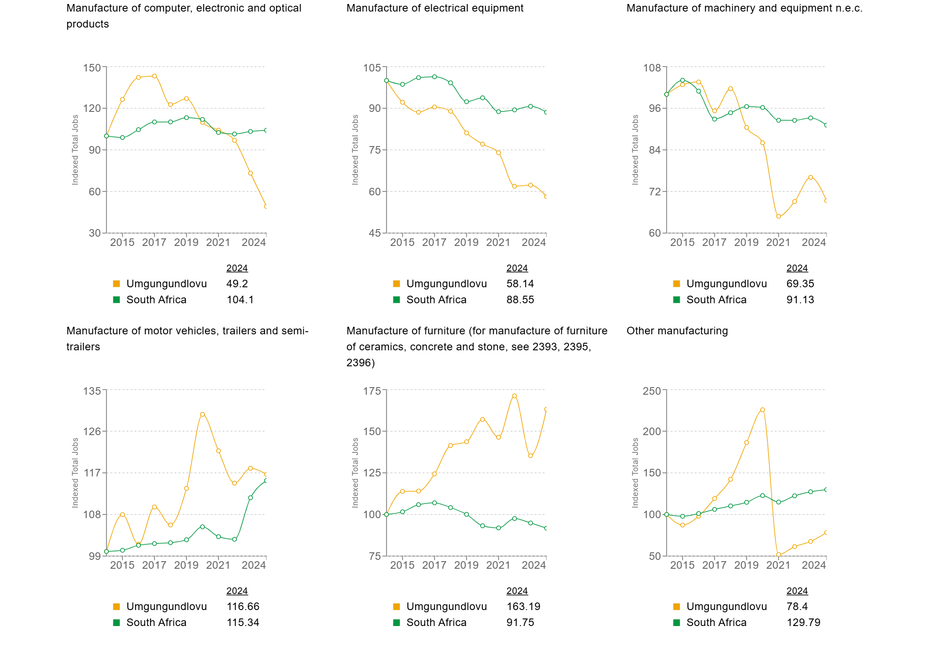

7.4 Agriculture, forestry and fishing

The uMgungundlovu District Municipality, located in the KwaZulu-Natal Midlands, is a significant hub for agriculture, forestry, and fishing, contributing approximately 10-15% to the district's economy.

Agriculture: The district's fertile soils and favorable climate support a diverse range of agricultural activities. Key crops include sugarcane, maize, and various vegetables. Livestock farming, particularly cattle and poultry, also plays a vital role in the region's agricultural output. Additionally, agro-processing industries, such as sugar milling and food production, are prominent in the area.

Forestry: The forestry sector is well-established, especially in areas like Richmond, with plantations growing at an annual rate of approximately 3%. Major companies like Mondi and Sappi have a significant presence in the region, focusing on timber production and processing.

Fishing: While specific data on the fishing industry within uMgungundlovu is limited, the district's abundant water resources, including six significant rivers and five major dams, provide potential for both commercial and subsistence fishing activities.

Overall, the agriculture, forestry, and fishing sectors are integral to uMgungundlovu's economy, leveraging the region's natural resources to drive growth and development.

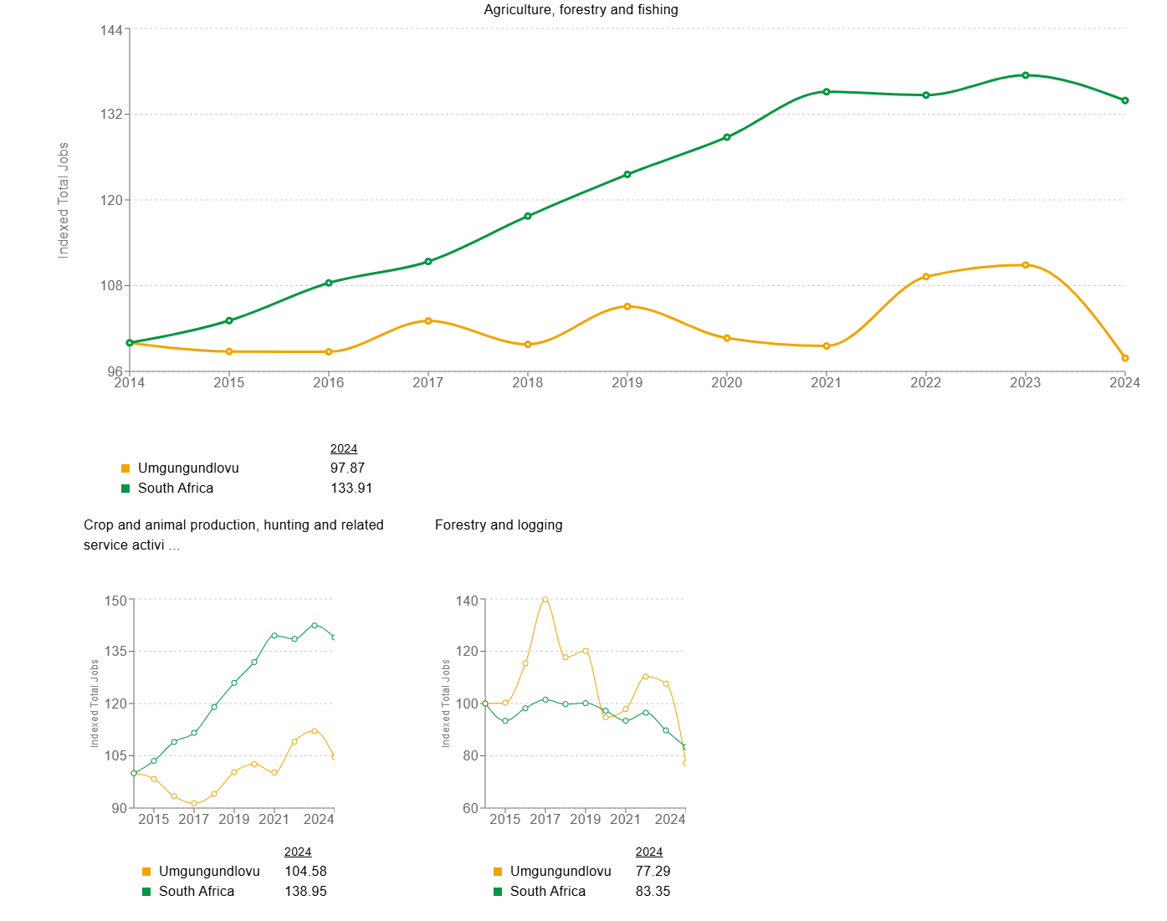

7.5 Mining and quarrying

The mining and quarrying sector in the uMgungundlovu District Municipality, located in KwaZulu-Natal, South Africa, plays a relatively minor role in the region's economy. According to the district's economic profile, mining and quarrying contribute approximately 1.84% to the Gross Value Added (GVA), indicating a limited impact compared to other sectors.

The district's economy is predominantly driven by manufacturing, finance, business services, and government activities. While specific data on mining operations within uMgungundlovu is limited, the presence of quarries suggests localized extraction activities, primarily focused on providing materials for construction and infrastructure projects.

Overall, while mining and quarrying exist within the uMgungundlovu District, they remain relatively small contributors to the local economy, overshadowed by more dominant sectors such as manufacturing and services.

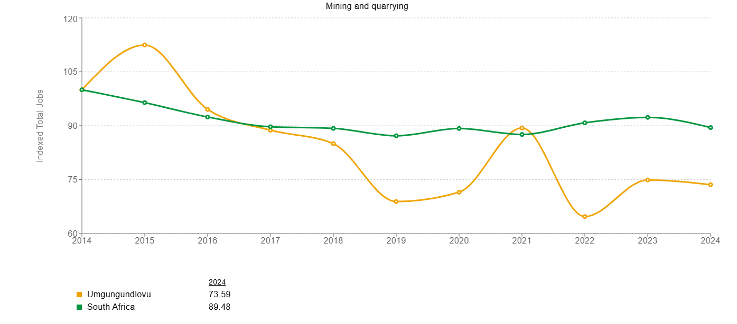

7.6 Education

The uMgungundlovu District Municipality in KwaZulu-Natal, South Africa, is home to several higher education institutions, notably the University of KwaZulu-Natal (UKZN) and the Umgungundlovu Technical and Vocational Education and Training (TVET) College.

The uMgungundlovu District Municipality in KwaZulu-Natal, South Africa, offers a diverse array of educational institutions, ranging from esteemed private schools to reputable public high schools
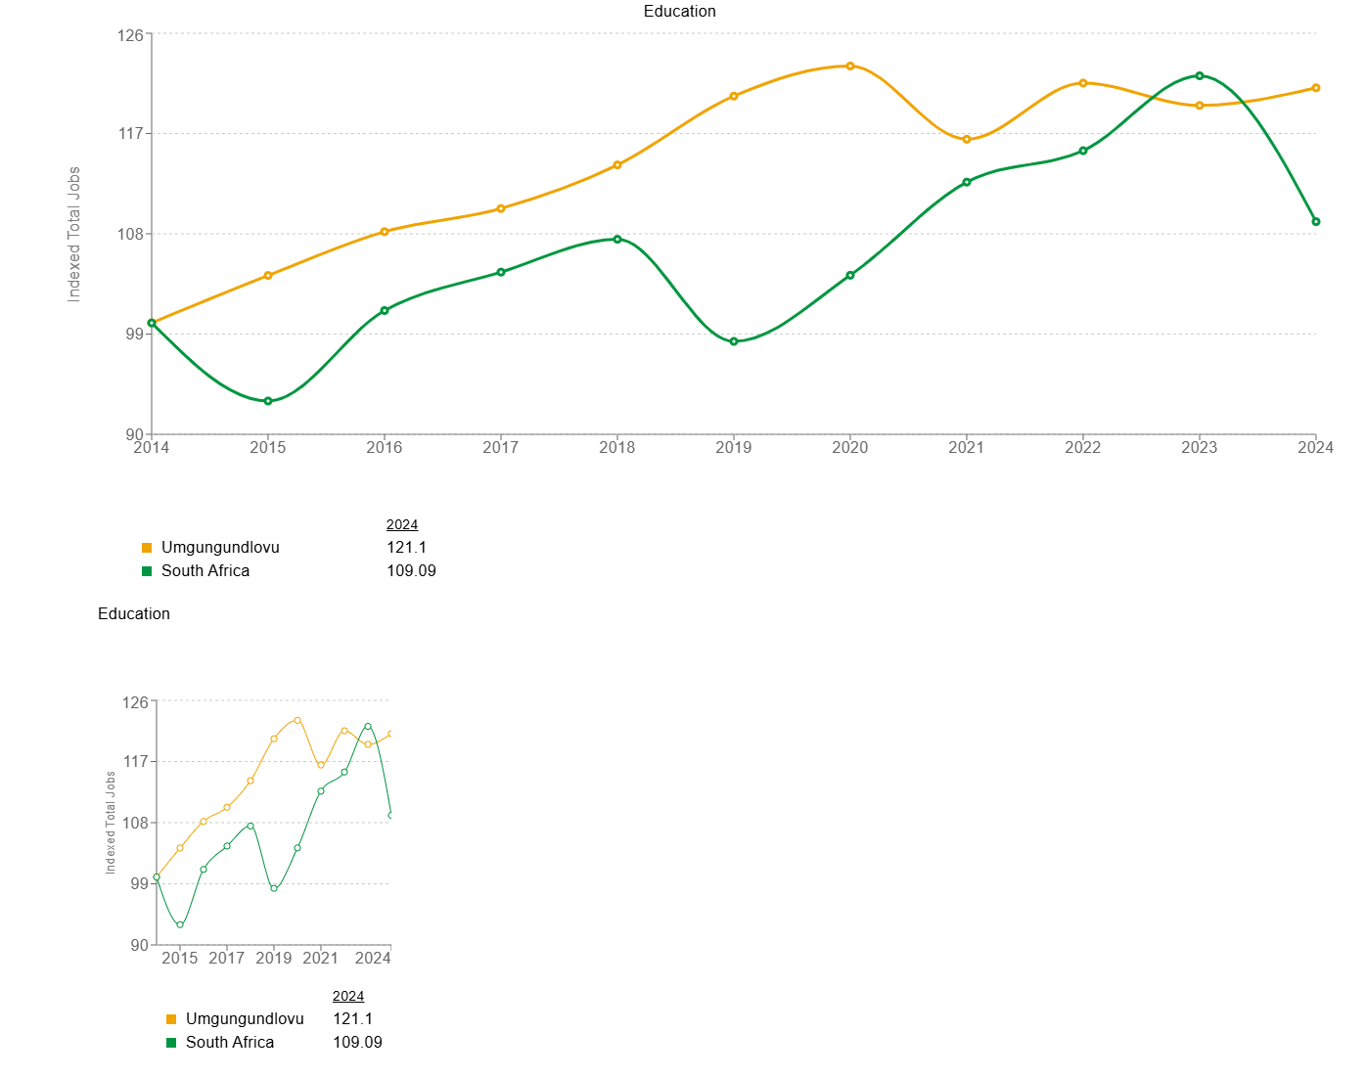

7.7 Electricity, gas, steam and air conditioning supply

The uMgungundlovu District Municipality in KwaZulu-Natal, South Africa, oversees the provision and maintenance of essential services, including electricity, gas, steam, and air conditioning supply. While the district's Integrated Development Plan (IDP) for 2020/2021 outlines strategies for infrastructure development and service delivery, specific details about the electricity, gas, steam, and air conditioning sectors are limited.

Electricity Supply:
Electricity distribution in the district is primarily managed by the local municipalities, with oversight from the uMgungundlovu District Municipality. The district has issued tenders for the supply and delivery of maintenance electric stock, indicating ongoing efforts to enhance electrical infrastructure.

Gas, Steam, and Air Conditioning Supply:
Information on gas and steam supply within the district is not prominently featured in the available sources. However, the district has initiated projects related to air conditioning systems, as evidenced by tenders for the supply and installation of air conditioning units in municipal facilities.

Infrastructure Development:
The district's economic profile emphasizes the importance of infrastructure development in supporting economic growth. Investments in energy infrastructure, including electricity and air conditioning systems, are crucial for the efficient functioning of both public services and private enterprises.

7.8 Human health and social work activities

The uMgungundlovu District Municipality in KwaZulu-Natal, South Africa, encompasses a comprehensive framework for human health and social work activities, serving a population of approximately 1,052,730 residents.
Health Services
The uMgungundlovu Health District operates under the KwaZulu-Natal Department of Health, delivering healthcare services across seven local municipalities: uMshwathi, uMngeni, Mpofana, Impendle, Msunduzi, uMkhambathini, and Richmond. The district spans an area of 9,189 square kilometres’ and provides healthcare to about 10% of the provincial population, with approximately 84.3% of residents being uninsured.
Social Work Services
The Community Services Department within the uMgungundlovu District Municipality oversees social development initiatives, including social work services. This department addresses various community needs, such as disaster management, fire and emergency services, environmental services, youth development, and project coordination.
Additionally, individual social workers operate within the district, providing essential support to vulnerable populations. For instance, professionals like Ms. Karen Shannon Bhagwandeen and Ms. Felicia Phumzile Buthelezi offer social work services in Pietermaritzburg, contributing to the district's social welfare framework.

7.9 Construction

The construction sector in the uMgungundlovu District Municipality, KwaZulu-Natal, contributes approximately 4.36% to the district's Gross Value Added (GVA), indicating a moderate role in the local economy.
Key Projects and Initiatives
Several construction projects have been undertaken to enhance infrastructure and public facilities within the district:
School Repairs: Notable projects include the repair of storm-damaged schools in Pietermaritzburg, such as the Umgungundlovu Cluster 3 and Cluster 1 repairs, each involving construction and renovations of six schools.
Disaster Relief Infrastructure: The district has issued tenders for the supply and delivery of disaster relief materials, aiming to bolster infrastructure resilience against natural disasters.
Strategic Development Plans
The uMgungundlovu Economic Development Agency (UMEDA) focuses on unlocking the district's economic potential through infrastructure development, including construction projects that align with the Integrated Development Plan (IDP).

7.10 Wholesale and retail trade; repair of motor vehicles and motorcycles

The wholesale and retail trade sector, encompassing the repair of motor vehicles and motorcycles, plays a significant role in the economy of the uMgungundlovu District Municipality, KwaZulu-Natal, South Africa.
Sector Overview
This sector includes activities such as the sale of new and used vehicles, maintenance and repair services, and the sale of parts and accessories for motor vehicles and motorcycles.
Local Economic Development Initiatives
The uMgungundlovu Economic Development Agency (UMEDA) actively engages in initiatives to bolster economic growth within the district. For instance, in March 2024, UMEDA issued a tender for the supply and delivery of a seven-seater vehicle, reflecting ongoing efforts to enhance local trade and services.
Business Registration and Support
The uMgungundlovu District Municipality maintains a Suppliers Database Registration Form, encouraging businesses in the wholesale and retail trade sector, including those involved in motor vehicle and motorcycle repairs, to register. This initiative aims to streamline procurement processes and promote local enterprise development.
Strategic Location
Pietermaritzburg, the main city within the uMgungundlovu District, serves as both the capital and legislative hub of KwaZulu-Natal. Its strategic location enhances the district's appeal for wholesale and retail trade activities, particularly in the automotive sector.

7.11 Accommodation and food service activities

The accommodation and food service sector are a vital component of the uMgungundlovu District Municipality's economy, influenced by its diverse geography and strategic location.
Geographical and Economic Context
The district's varied landscape, encompassing urban centres like Pietermaritzburg and expansive rural areas, supports a range of hospitality services. Pietermaritzburg, serving as the provincial capital, attracts both business and leisure travellers’, fostering growth in hotels, guesthouses, and restaurants. The district's fertile valleys and scenic hills also promote agritourism and eco-tourism initiatives, further boosting accommodation and dining establishments.
Regulatory Framework
To maintain quality and safety standards, the uMgungundlovu District Municipality has established a tariff structure for services rendered at food and accommodation establishments. This includes fees for health certifications and inspections, ensuring compliance with local regulations and promoting consumer confidence in the services provided.
Accommodation Options
A variety of lodging options are available within the district, catering to diverse preferences and budgets. Platforms like Airbnb list numerous properties, ranging from farm stays to urban apartments, reflecting the region's blend of rural charm and urban convenience.
Food Service Establishments
The district boasts a wide array of food service establishments, from local eateries offering traditional South African cuisine to upscale restaurants providing international dishes. These establishments not only serve residents but also enhance the tourism experience for visitors.
Tourism and Economic Development
The accommodation and food service sector significantly contributes to the district's economic development by creating employment opportunities and supporting local supply chains. The uMgungundlovu Economic Development Agency (UMEDA) actively promotes tourism and related services, recognizing their role in the district's growth and sustainability.

In summary, the accommodation and food service sector in the uMgungundlovu District Municipality thrives on the region's strategic location, diverse geography, and supportive regulatory environment, playing a crucial role in its economic landscape.

Accommodation and food service activities (Continue)

7.12 Transportation and storage

The uMgungundlovu District Municipality in KwaZulu-Natal, South Africa, places significant emphasis on the development and maintenance of transportation infrastructure and storage facilities to bolster economic growth and service delivery.

Transportation Infrastructure
The district's strategic location is underscored by the N3 national highway, which traverses the area, linking Gauteng and Durban. This major transport route facilitates efficient movement of goods and people, enhancing the district's connectivity and economic prospects. Additionally, the R56 provincial arterial route runs north-south through the municipality, further strengthening its transportation network.
The uMgungundlovu District Municipality's Integrated Development Plan (IDP) highlights the importance of transportation infrastructure in promoting economic development and improving access to services.

Storage Facilities
Efficient storage solutions are crucial for both municipal operations and economic activities. The municipality has recognized this need, as evidenced by tenders such as REQ05163, which sought providers for off-site storage facilities and document management services.
Moreover, the district hosts various storage service providers, including cold storage facilities like Banda Cold Rooms in Pietermaritzburg, offering specialized storage solutions to meet diverse requirements.

Strategic Focus
Both transportation and storage sectors are integral to the district's economic framework. The uMgungundlovu Economic Development Agency (UMEDA) continues to explore opportunities to enhance these sectors, aiming to reduce infrastructure backlogs, improve access, and bolster economic activities within the region.

INDUSTRY PROFILE (2024
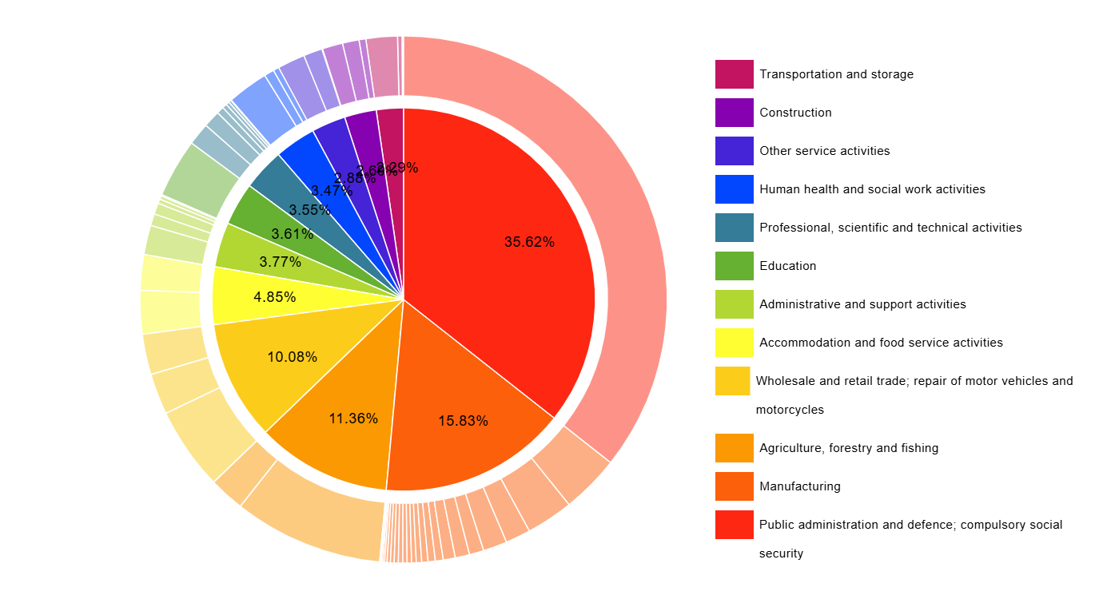

What is the structure of industry in Umgungundlovu?
Total jobs are split up across industries for sectors (inner pie) and sub-sectors (outer pie) to provide a detailed overview of the structure of local industry. Industries are defined according to the Standard Industrial Classification of all Economic Activities (seventh edition) which includes up to 90 divisions (sub-sectors in the outer pie) for an in-depth review.

Industry Potential: Four Quadrants (2014-2024 | All Industries)

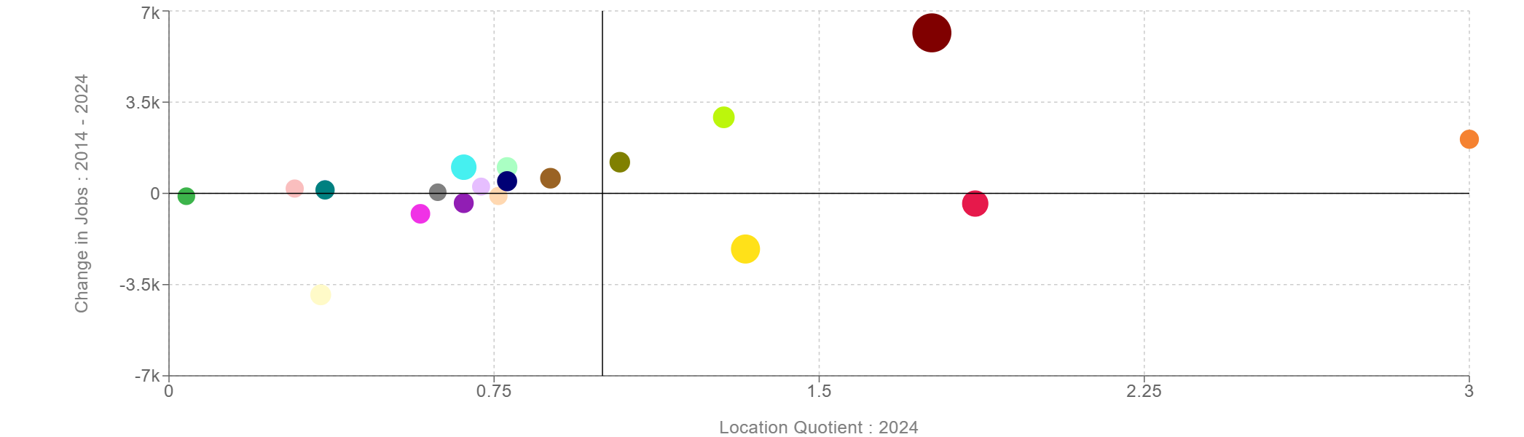

Public administration and defense; compulsory social security Manufacturing
Agriculture, forestry and fishing
Wholesale and retail trade; repair of motor vehicles and motorcycles Accommodation and food service activities
Administrative and support activities Education
Professional, scientific and technical activities Human health and social work activities other service activities
Construction Transportation and storage
Financial and insurance activities
Water supply; sewerage, waste management and remediation activities Arts, entertainment and recreation
Information and communication Real estate activities
Electricity, gas, steam and air conditioning supply Mining and quarrying
Activities of extraterritorial organizations and bodies, not economically active people, unemployed people etc.

Wage Inequality: Gini

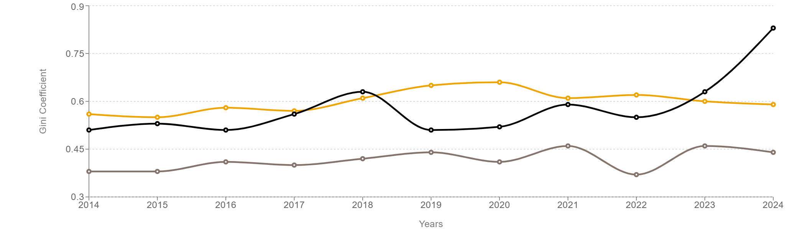

 | 2024
Umgungundlovu | 0.59
Alfred Nzo | 0.44
John Taolo Gaetsewe | 0.83

The wage Gini calculated from tax data is a measure of inequality amongst wage earners who work in the formal sector and is very different to measuring income inequality amongst all workers or amongst households (which would also include the unemployed). Wage inequality remains a fundamental driver of income inequality in South Africa.

Wage Levels: Median Income
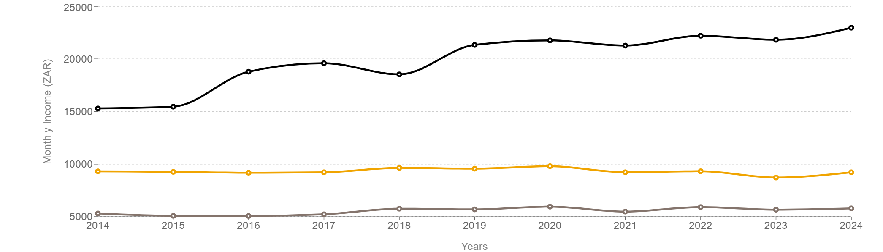

 | 2024
Umgungundlovu | 9224
Umkhanyakude | 5792
Waterberg | 22968

12. Wage Distribution (2024 All Industries)
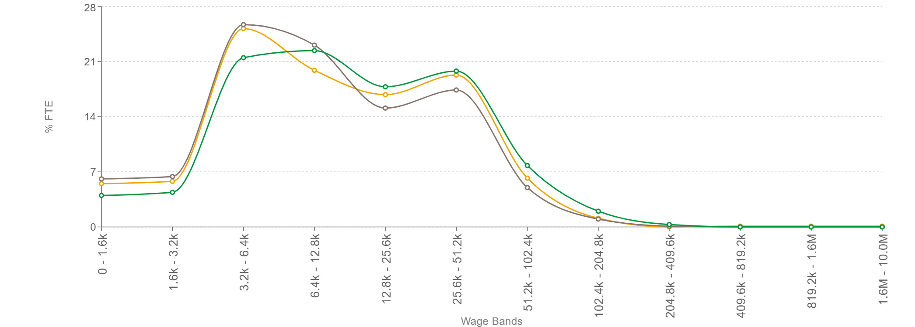
UMGUNGUNDLOVU
 KZN
 SOUTH AFRICA

Jobs For Youth (2024)

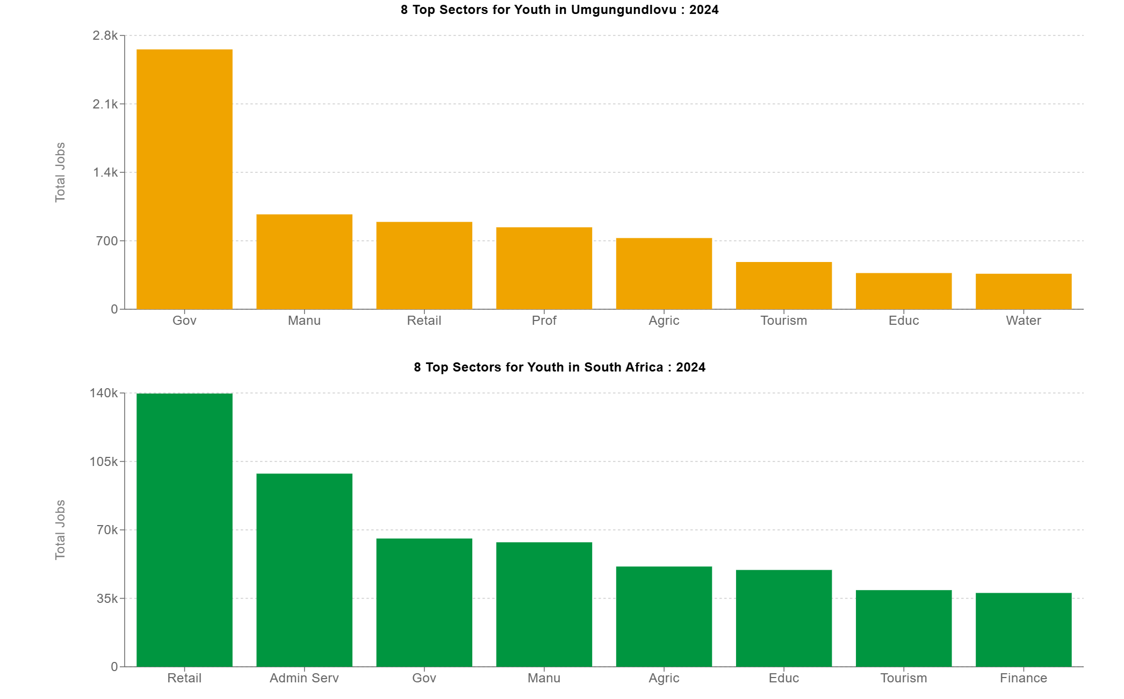

Which industries offer the most jobs for youth in Umgungundlovu?
Industries which create more job opportunities for young people can also play a development role within society. The total number of jobs for youth (aged 15 - 25) related to the intensity of youth employment in that sector along with total industry size. A higher youth jobs intensity (share of jobs for youth within the sector) is preferable although sheer industry size can lead to jobs for youth because of volume.

TOURISM TRENDS

Tourism can be defined as the non-commercial organization plus the operation of vacations and visits to a place of interest. Whether you visit a relative or friend, travel for business purposes, go on holiday or on medical and religious trips - these are all included in tourism.
Recent developments indicate a positive trajectory for tourism business confidence in the uMgungundlovu District. On December 5, 2024, the uMgungundlovu District Municipality Tourism Forum convened, emphasizing collaboration between local municipalities and private sectors to foster sustainable tourism growth. Chaired by Mr. Sipho Ntuli, Divisional Manager of the uMgungundlovu District Municipality, the forum highlighted the district's commitment to supporting Community Tourism Organizations (CTOs). Notably, funds allocated by the district municipality have been transferred to the uMgungundlovu Economic Development Agency (UMEDA) to bolster CTO initiatives, reflecting a strategic focus on enhancing tourism infrastructure and services in the region.
Broader economic indicators suggest a favourable environment. In November 2024, South Africa's Business Confidence Index (BCI) experienced its most significant year-on-year improvement in nearly two years, rising to 118.1 from 114.2 in October. This surge was driven by higher tourist numbers, increased precious metal prices, and a rise in new vehicle sales, signalling a robust national economic outlook that likely benefits regional economies like uMgungundlovu.
These developments, coupled with strategic investments in tourism by local authorities, indicate a strengthening of tourism business confidence in the uMgungundlovu District
Cultural and Heritage Tourism Initiatives:
- In September 2024, the KwaZulu-Natal Tourism and Film Authority emphasized the province's cultural heritage during Tourism Month. Celebrations were held at the uMgungundlovu Multimedia Centre in Ulundi, highlighting the region's rich Zulu history.
Tourism Attractions:
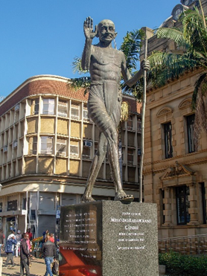
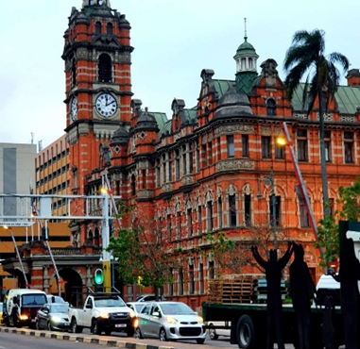
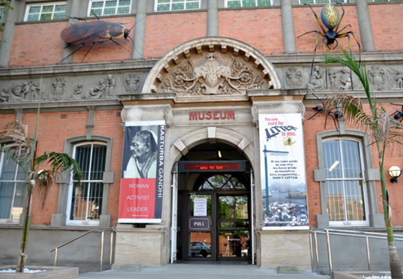
Historic city of Pietermaritzburg, known for its colonial architecture, the iconic City Hall and Museum.

The Midlands Meander ​: collection of arranged routes that offer visitors hospitality in truly beautiful surroundings, outstanding accommodation, conference and wedding facilities, fascinating local events, fabulous cuisine and restaurants, revitalizing outdoor activities and over-the-top adventure sports, historic landmarks, wildlife conservation, and unique arts and crafts

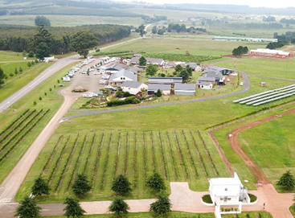
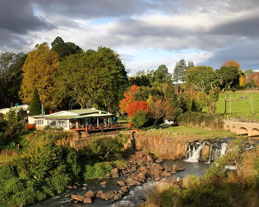

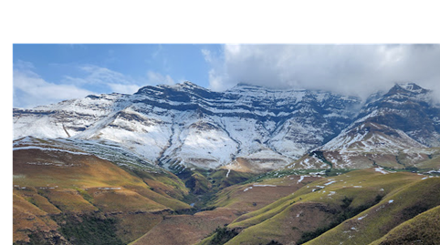
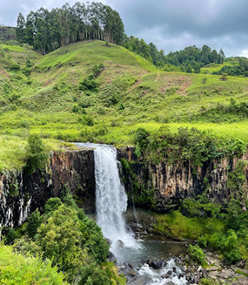
The uKhahlamba-Drakensberg Park, a UNESCO World Heritage Site, is in the district, enhancing its tourism potential.


Multiple sporting Events: This includes numerous facilities such as Athletic Stadium, Cricket Oval, Woodburn Stadium, Kershaw Tennis Stadium, Velodrome, BMX Club, Golden Horse Golf Village, Skatepark and many more.
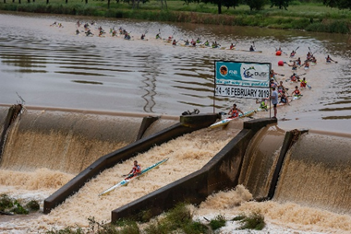
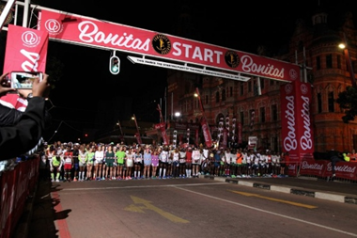
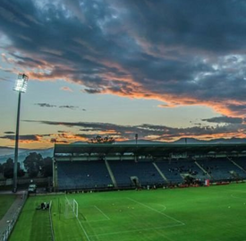

Howick Falls (The second tallest waterfall in South Africa) site is being upgraded to enhance the natural beauty of the site.
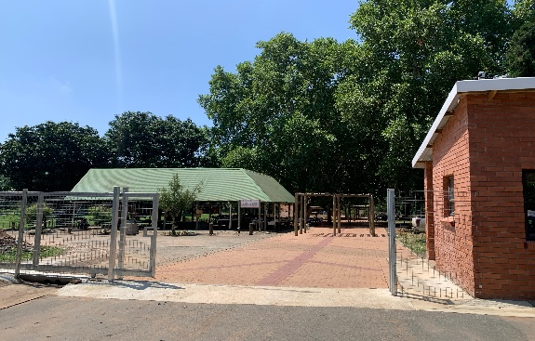
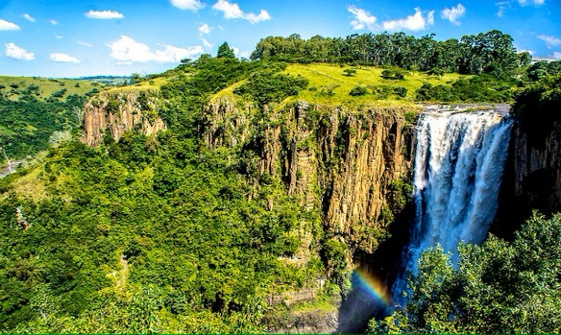

Nelson Mandela Capture Site
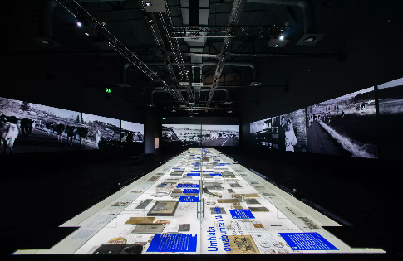
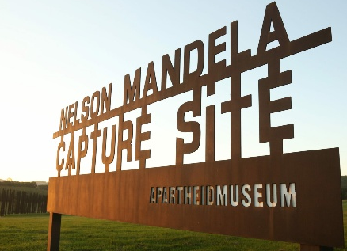


Economic Impact and Employment:
- The tourism industry in uMgungundlovu is primarily historic, cultural, and nature-based, contributing to local economic development and job creation. Sport tourism has grown in the district as with multiple facilities to hold events more out of town people come to visit the district.

TRANSPORT TRENDS

The uMgungundlovu District is a pivotal region for transportation serving as a conduit between major economic hubs. The district's transport infrastructure is anchored by the N3 Corridor, South Africa's busiest highway, which facilitates significant freight movement between Durban and Gauteng.
The district's strategic location adjacent to the eThekwini Metro, home to the country's busiest port, further amplifies its importance in national logistics and transportation. This proximity not only enhances the district's role in freight logistics but also positions it as a critical area for industrial, commercial, and retail expansion, especially in regions like Camperdown and Umlaas Road along the N3.
A reliable transport network is a fundamental driver of economic growth and accessibility. The district’s transport infrastructure comprises the following key components:

Road Infrastructure: The district benefits from well-maintained national and regional roads. Infrastructure is well kept as the N3 corridor is being upgraded to enhance traffic flow between Pietermaritzburg and Durban routes.

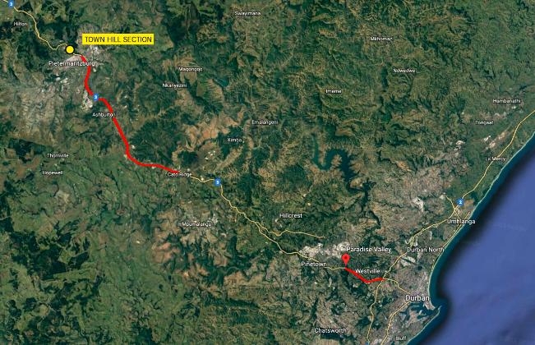
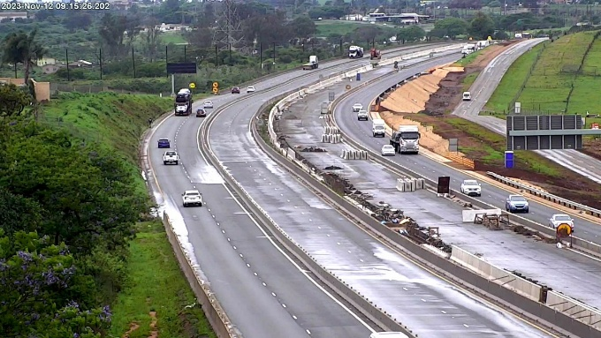

Public Transport: Minibus taxis and buses are the main modes of public transport.
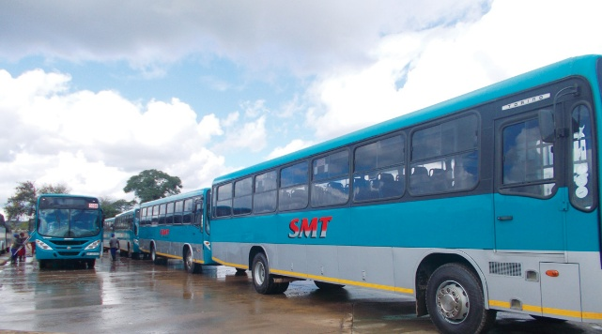
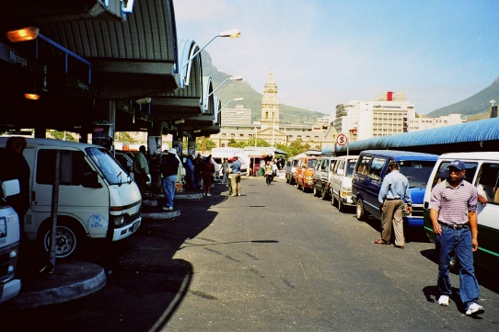

Oribi Airport: the airport serves as a crucial hub for both passenger travel and freight logistics, complementing the district's extensive road and rail networks. The airport is undergoing planning for upgrades.
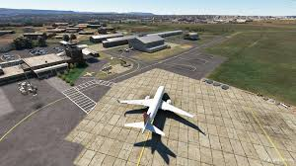

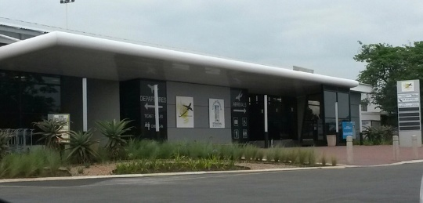

Role and advantage of the Informal Economy

The National Strategy for the Development and Promotion of Small business in South Africa notes the informal economy creates a significant contribution to the economic and social life of majority of South African population. These influences apply also to most of the residents in uMgungundlovu District and they include amongst others the following:
- It Absorbs workers who would otherwise be without work or income.
- Helps to meet the needs of poor consumers by providing accessible and low-priced goods and services.
- Could serve as an incubator for business potential and an opportunity for on-the-job skills acquisition. In this sense, it can be a transitional base for accessibility and graduation to the formal economy, if effective strategies are put in place.
- Apart from job creation, economic growth and equity created the informal economy provides a relatively easy entry point into the first economic activity for those previously excluded.
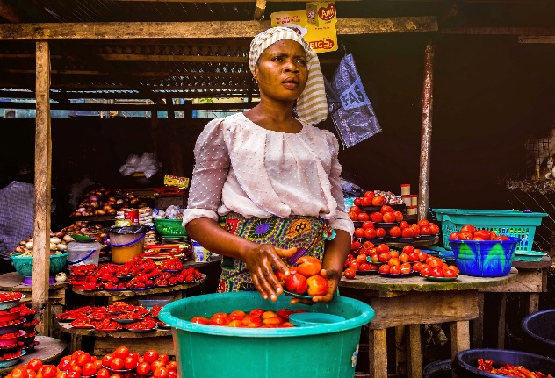
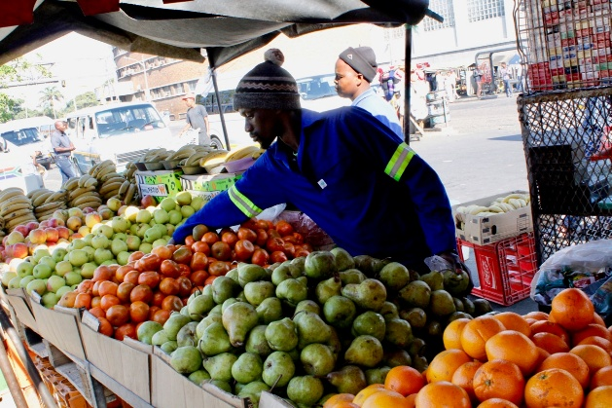

The Educational Sector in uMgungundlovu District

The educational sector in uMgungundlovu District is quite comprehensive and diverse. The district also includes a range of private tertiary institutions providing education through personalized learning tailored to each student’s strengths, fostering critical and creative thinking. The demand for skills-based training and entrepreneurial education is growing, creating investment prospects in private colleges, technology-driven learning solutions, and corporate training partnerships. The district has a variety of educational institutions spread across seven local municipalities: Impendle, Mkhambathini, Mpofana, Msunduzi, Richmond, uMngeni, and uMshwathi.
The district has a network of public and private schools catering to diverse educational needs. Some of the notable schools include:

17.1 Tertiary Education and Vocational Training

University of KwaZulu-Natal (UKZN) - The University of KwaZulu-Natal (UKZN) Pietermaritzburg campus is a relatively small institution that offers a variety of undergraduate and postgraduate programs. The campus is in Pietermaritzburg, close to parks and nature reserves.
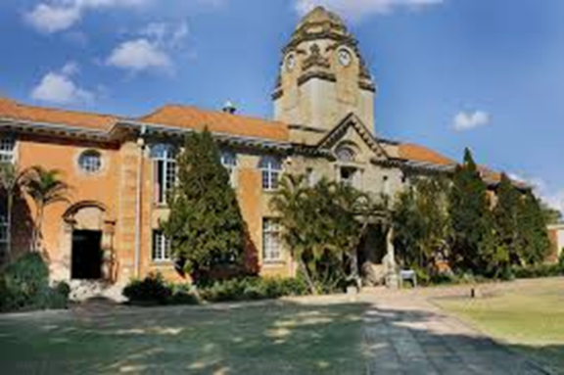
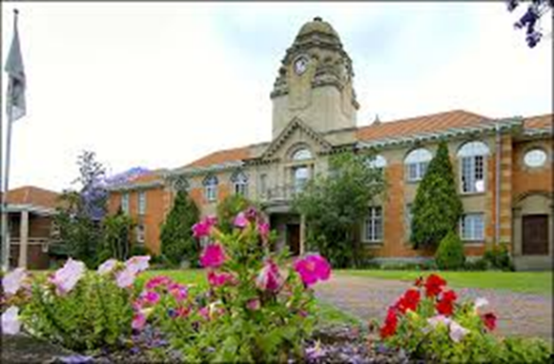

DUT (Durban University of Technology) - The Durban University of Technology (DUT) in Pietermaritzburg (PMB) is a multi-campus university that offers higher education and technological training.
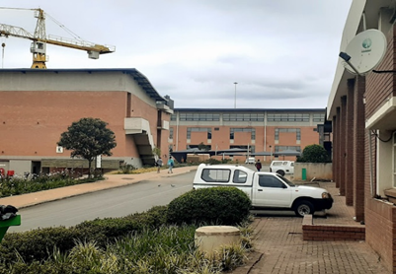
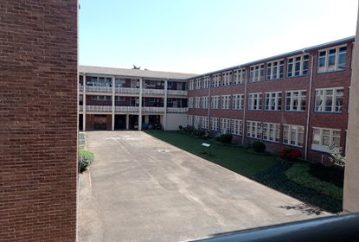

17.2 Private Schools:

Maritzburg College - A prominent high school is a public school for boys in Pietermaritzburg, KwaZulu-Natal. It is a semi-private English-medium high school for boys situated in the city of Pietermaritzburg in the KwaZulu-Natal province of South Africa. It is the oldest boys' high school in KwaZulu-Natal, and one of the oldest schools in South Africa.

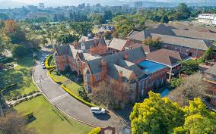

Epworth School - An independent, Christian school that takes pride in preparing our pupils for a future where they are confident, knowledgeable and multi-faceted. Has consistently achieved a 100% pass rate in the Independent Examinations Board (IEB) National Senior Certificate examinations
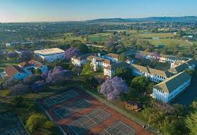
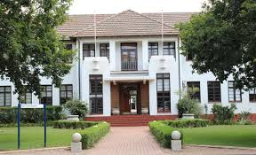

Hilton College, more commonly referred to as Hilton, is a South African private boarding school for boys located near the town of Hilton in the KwaZulu-Natal Midlands and is situated on a 1,762 ha (4,350 acre) estate that includes a 550 ha (1,400 acre) wildlife reserve and the 150 ha (370 acre) school campus Hilton College’s matric class of 2024 achieved a 100% pass rate. This was in addition to an average of 2.6 A symbols per candidate.
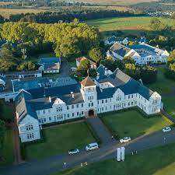


Michael house School is a full boarding senior school for boys founded in 1896. It is in the Balgowan valley in the Midlands of KwaZulu-Natal, South Africa. It has achieved a 100% pass rate in the 2024 Independent Examinations Board (IEB) exams. This included all students receiving bachelor’s degree passes.
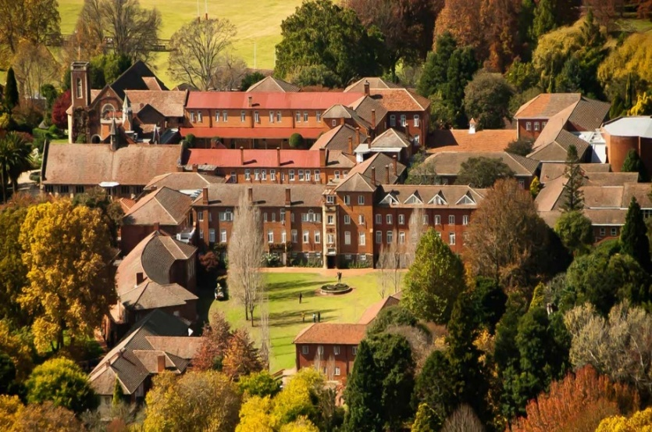
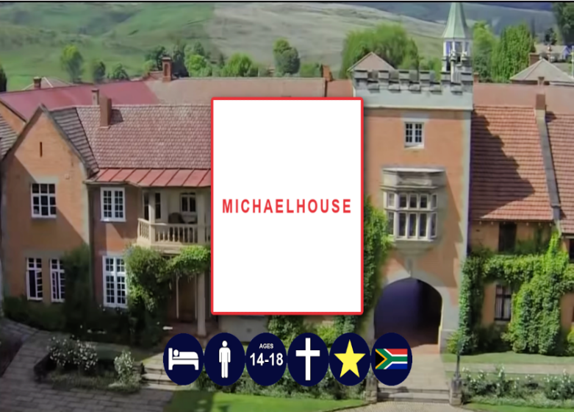

St Charles College is a Christian, independent boys college situated in Pietermaritzburg, South Africa, catering for day boys from Grade 000 to Matric, with boarders from Grade 4 upwards.100% pass rate
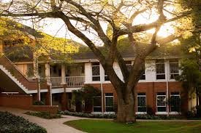


Russell High School is a public high school for girls, located in the city of Pietermaritzburg, KwaZulu-Natal, South Africa. Russell High School pass rate 2024 is 96.2%. This confirms that the school increased the pass rate compared to 95.9% of 2023

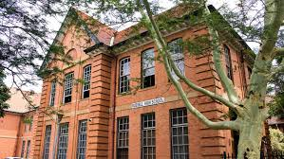

DATA SOURCES:



